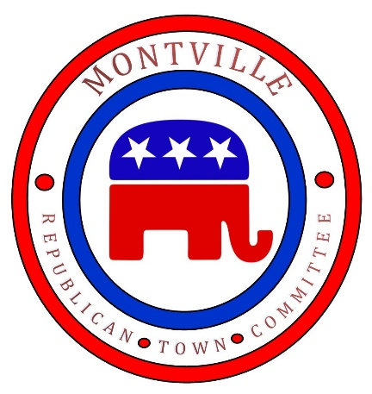

Dear Residents of Montville,

We want to inform you about two important upcoming events that will require your attention and participation.

**Public Hearing**

A **Public Hearing** will be held at the Montville Town Hall on **April 7, 2025, at 6:00 PM**. This hearing will provide an opportunity for all residents to learn more about and voice their concerns regarding a proposed $1.5 million bond for the purchase of the “Bond Gravel Pit & Property” to be placed into open space. It is important that you attend so to ensure transparency and fully understand the implications of this proposed financial decision.

**Town Meeting**

A **Town Meeting** will follow on **April 9, 2025, from 4:00 PM to 7:00 PM** at the Montville High School Auditorium. During this meeting, residents will vote on whether the Town of Montville should approve the proposed $1.5 million bond to fund a project involving the **Avalonia Land Conservancy, Inc.**

**Our Position**

The **Republican position** on this matter is clear: **VOTE NO:** **Taxpayers should not be responsible for paying a loan with interest to be gifted to a nonprofit organization, the Avalonia Land Conservancy.** When Avalonia acquires the “Bond Gravel Pit & Property” it will then be placed into conservatory status, but will then be granted a **Tax Abatement**, meaning that Montville will lose out on property tax revenue. This will place an additional financial burden on Montville taxpayers, who will be expected to bear the costs without receiving any benefit in return. Moreover, Montville will have no control over the property’s usage, yet we will still be responsible for providing essential police and fire protection services. It is obviously clear that the **Democrats** want the residents to continue giving, even if it comes at a cost to our town’s financial health.

Additionally, it is important to note that **Montville’s Democrat Delegation, to include State Senators Kathy Osten and Martha Marx, along with State Representatives Kevin Ryan, Nick Gauthier and Nick Menapace** are in favor of this proposal, which raises concerns. It seems highly suspect that the Democrats, in particular, would support taxpayers funding their pet projects, such as this one, at a time when we are already facing significant financial challenges.

We urge you to come to the **Public Hearing** on **April 7** and participate in the **Town Meeting** on **April 9**. Your vote will help determine whether Montville residents should take on this financial burden. We strongly encourage you to make your voice heard and ask the tough questions about the implications of this proposal.

Thank you for your attention to this important matter. Your participation in these events will play a crucial role in shaping the future of Montville.

**PAID FOR BY THE MONTVILLE REPUBLICAN TOWN COMMITTEE – WILLS PIKE, TREASURER**